786
Name: Muhammad Sherjeel Akhtar
Roll No: 20p-0101
Subject: Computer Network Lab
Task No: 07
Submitted To Respect Ma’am: Miss Hurmat Hidayat
Section: B

Task 1: WLAN Configuration on Packet Tracer

Our laptop doesn’t has a wireless connection so first we turn off our laptop and remove the following parts by shutting down our laptop.
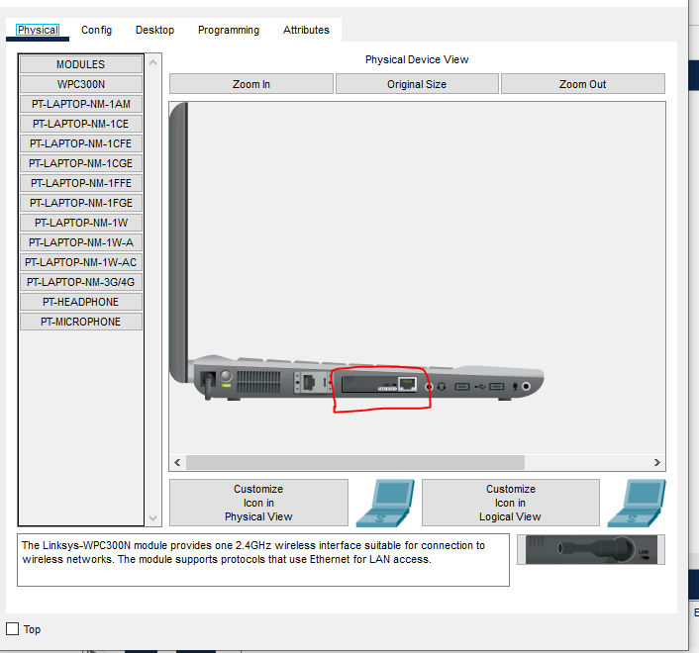
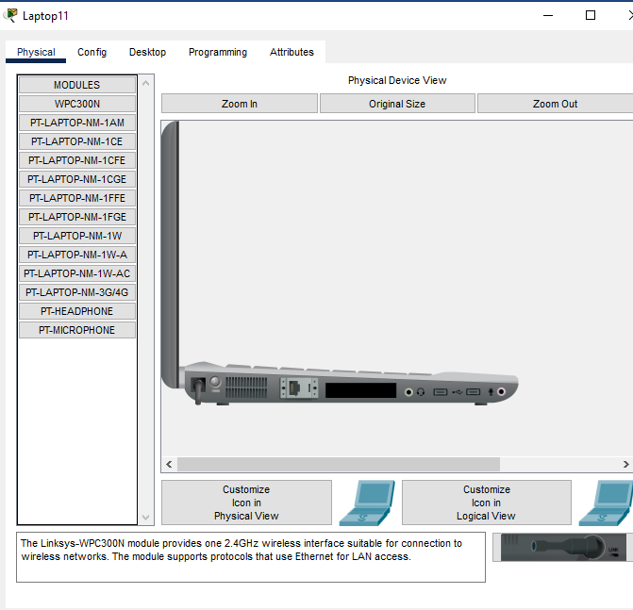
Adding The Wireless Network Adapter:
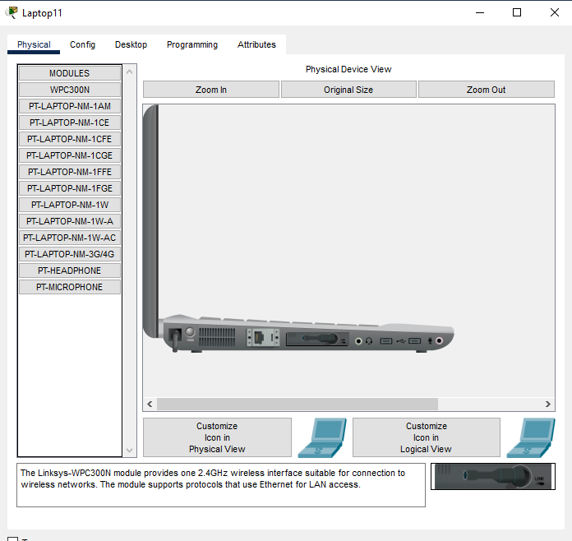

Topology:
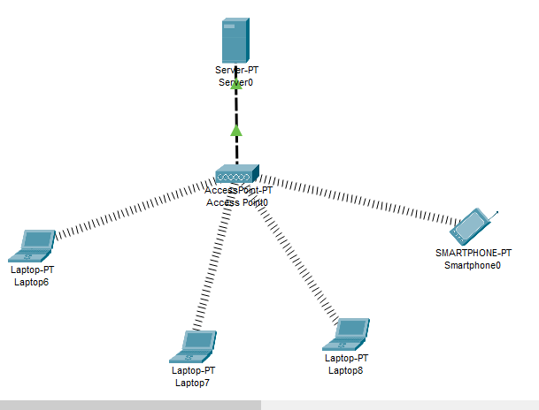

Now after connecting all the wireless devices to the access point then after that when we check the DHCP connection it is failing so we set our DHCP server
Server Configuration:
This server will give IP addresses to our devices who are connected to the Access Point.
Services Tab Setting:
In the Services tab of Server, we will go through the DHCP at the left hand. In here, we will define
IP Pool:
Our IP Pool. For this configuration example our DHCP Pool’s name is “IPCisco Pool”. Beside, we will

Default Gateway Configuration:
Configure the Default Gateway, DNS Server IP addresses. After that we will configure the starting
IP And Subnet Mask Assignment:
IP and Subnet Mask. DHCP server will start IP assignation with this IP. And for this example, we have
Created 254 IP for our IP Pool. We also assign this value on this screen.

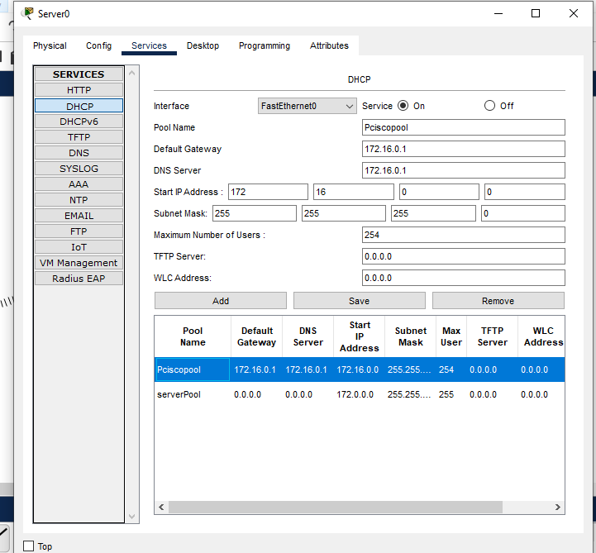

“Turning On The DHCP Services.”

Set the server IP Address to “172.16.0.1”.
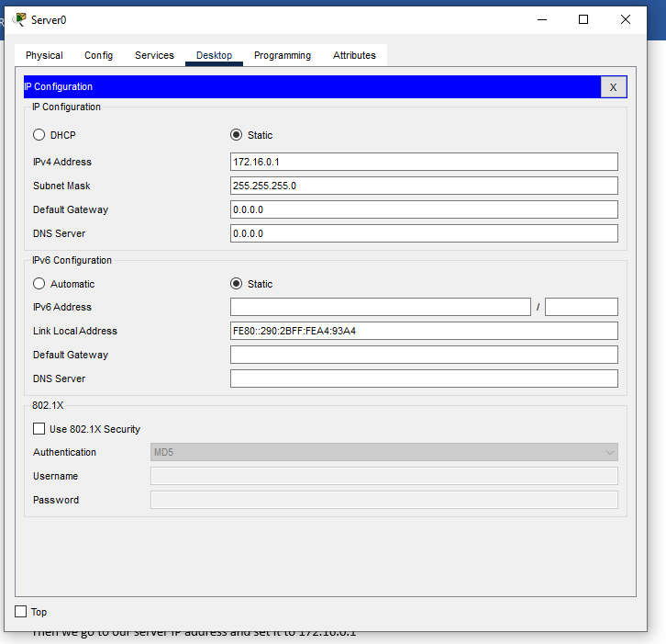

Check DHCP Connection On Laptops.
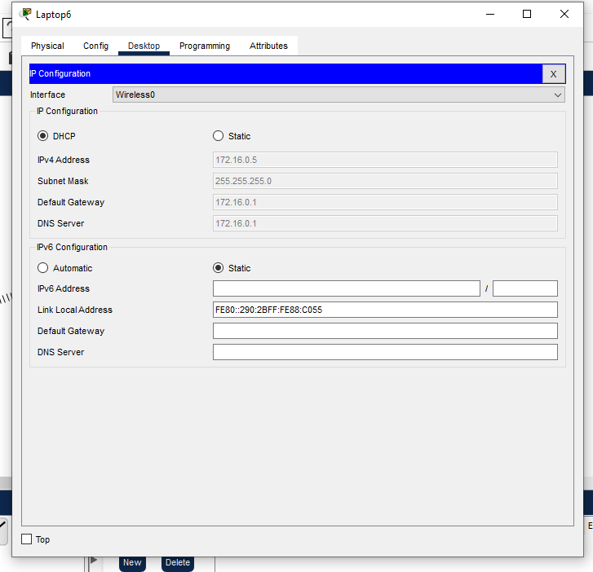
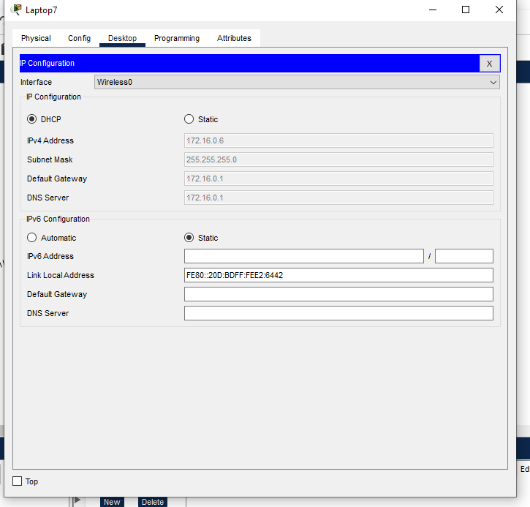
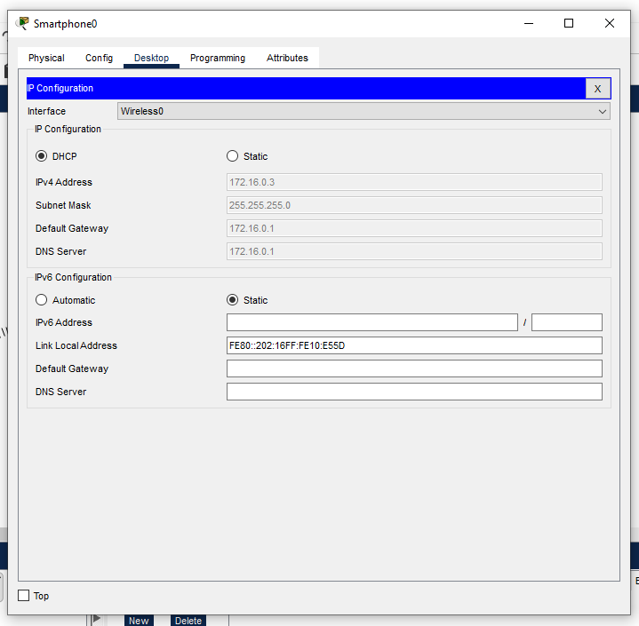

Pinging PC To Test The Connection:
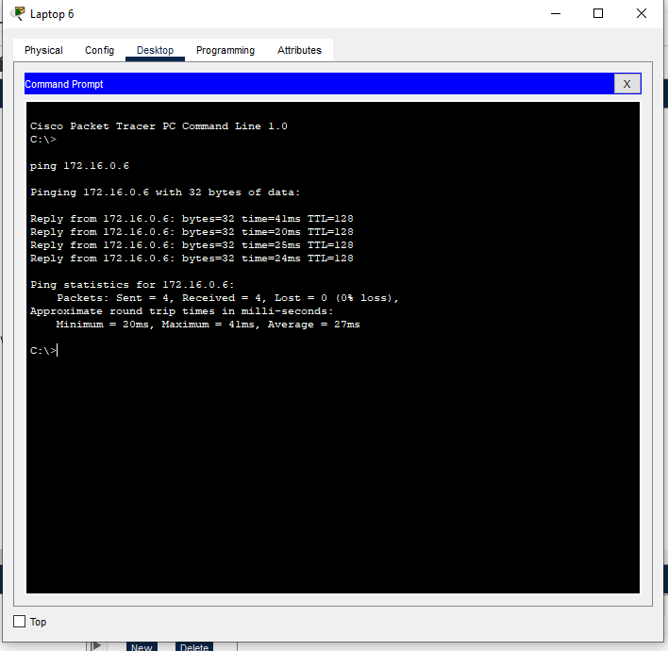

Task 2: WAN Router configuration in Cisco Packet Tracer

First we pick a wireless router and two laptops, a PC, a generic server and a 2800-series router(or just any other router other than wireless).
Make sure that you first power off each laptop before you make any replacement then restore the Power back after replacement.
Once you have the wireless modules in place, you’ll see the wireless connections come up between the laptops and the wireless router as shown below.

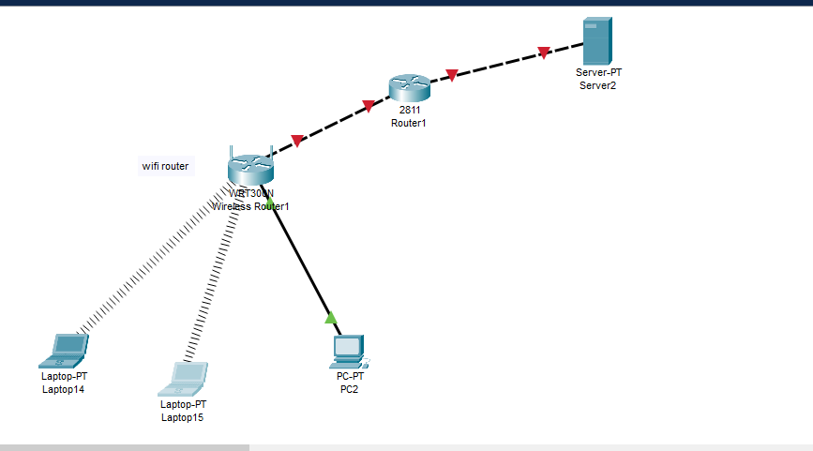

Then we open our laptop and go to browser and click on the default IP of the wireless router. So we go on web and search the IP address it will display a page asking for username and password which is default admin and admin

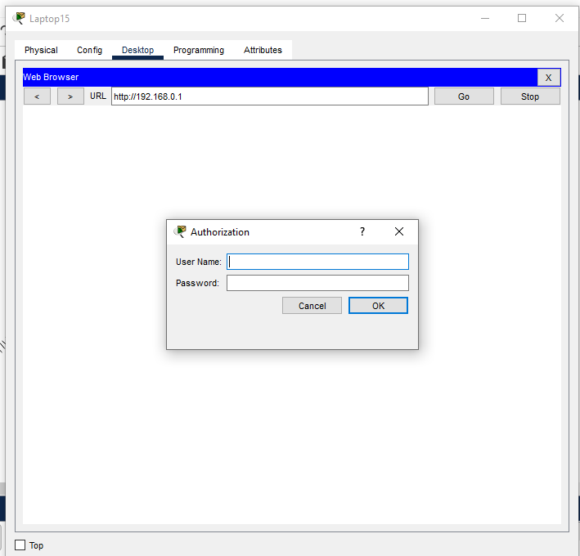

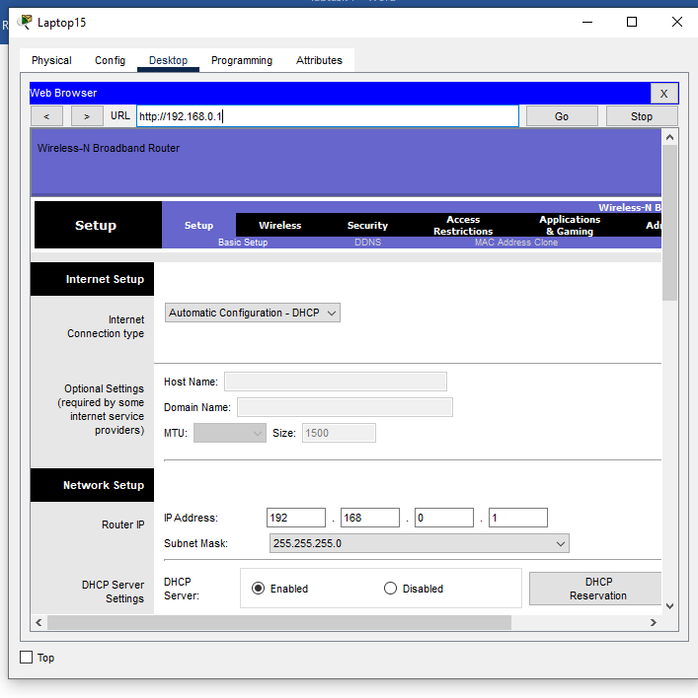

We logged in to the wireless router GUI .
And now we are going to change the password for the wireless router

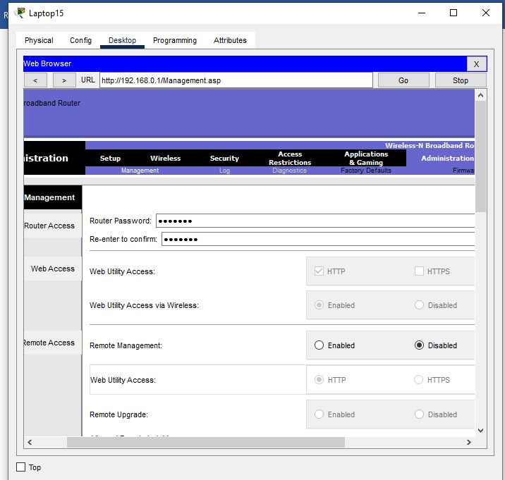

Changing Password:
We change our password from admin to fast123

LAN Setup and Internet Setup:

Network Setup Already, we have a PC and three laptops in the LAN.We’ll assign
The them IP addresses either statically or dynamically (using a DHCP pool set up in the wireless
Router we will go to the network setup then we change start IP address to 192.168.0.50 and max users to 50 and save settings

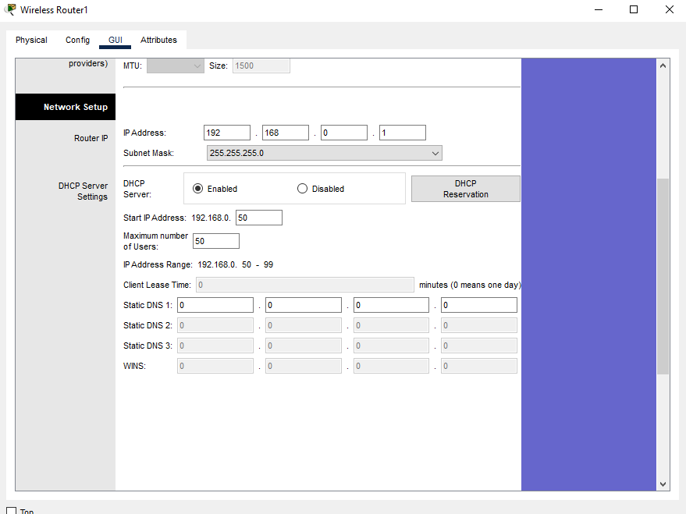

And then go to check let’s enable DHCP on each PC for dynamic configuration. Go to the IP Configuration tab for each PC and enable DHCP. Each PC should automatically obtain an IP address from the router.

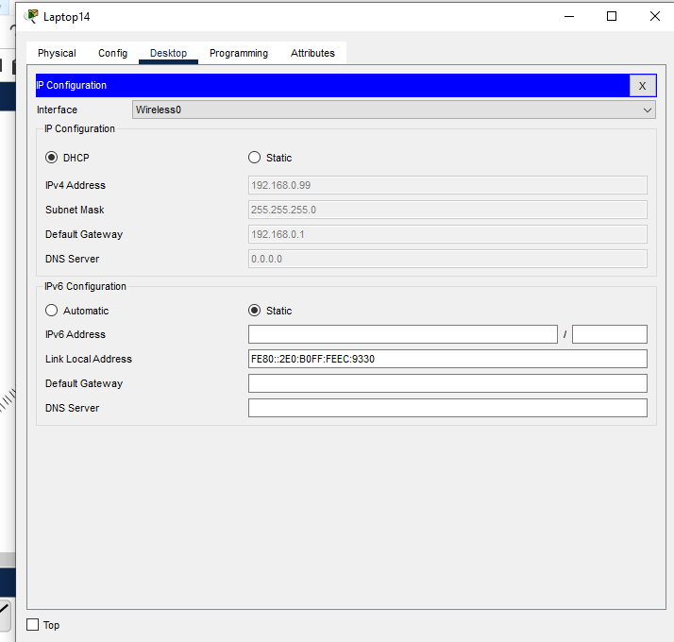

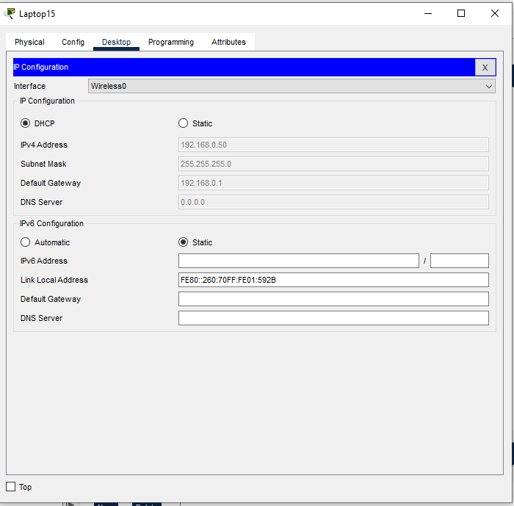

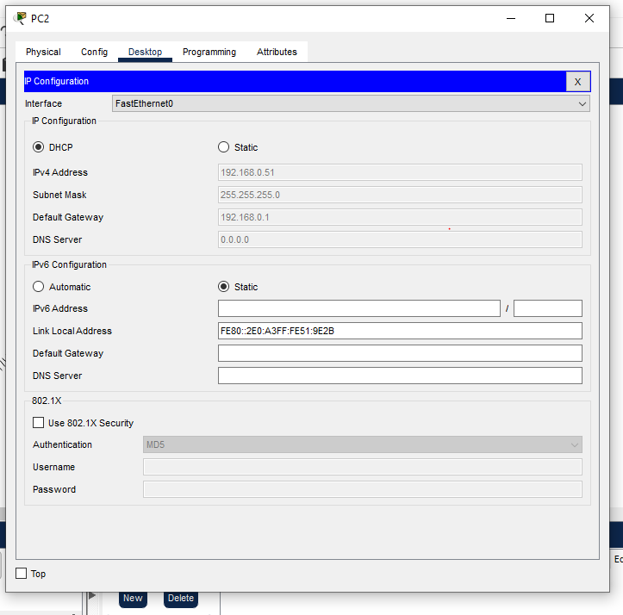
Ping Test Between Laptops:
Then we ping from laptop 1 to laptop 2
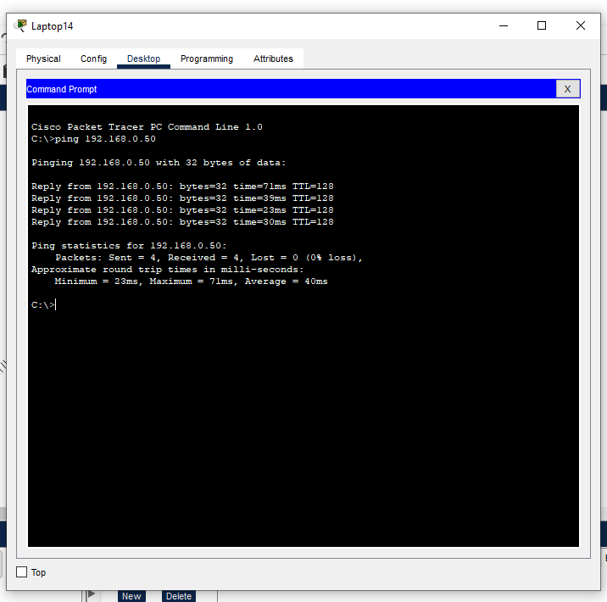
Changing Name Of The Router:
Then we move on to wireless portion and change the name of the router
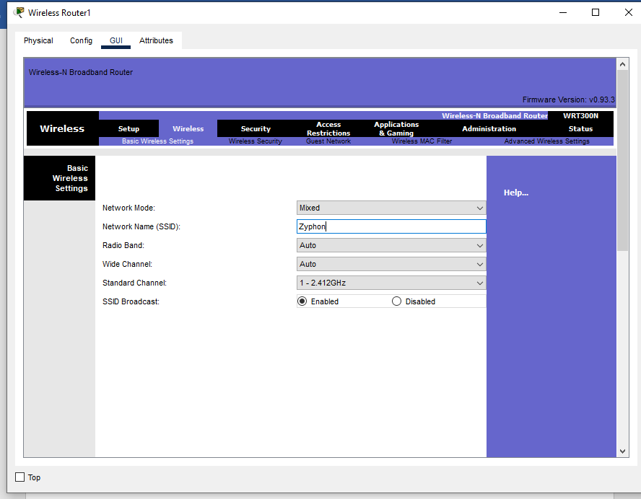
Setting Security For The Router:
Then we go on wireless security and set the security for our router
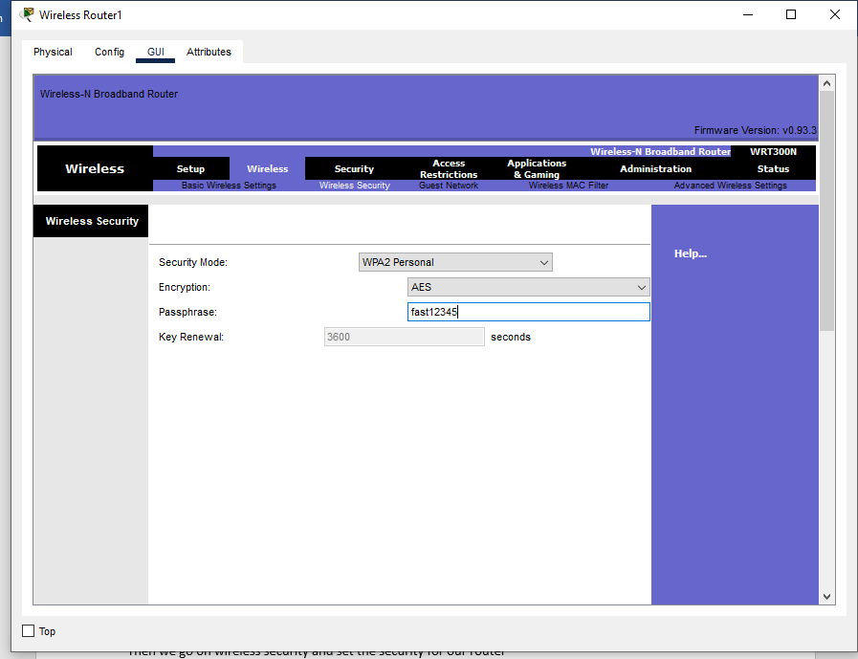

And click save.
Then to check if our wireless router is their we go on laptop go to Desktop and then go to wireless and we get a page like this which shows our router name.
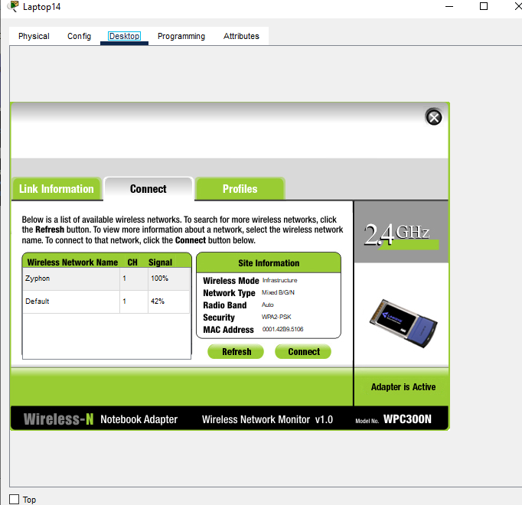

Now we connect to it.
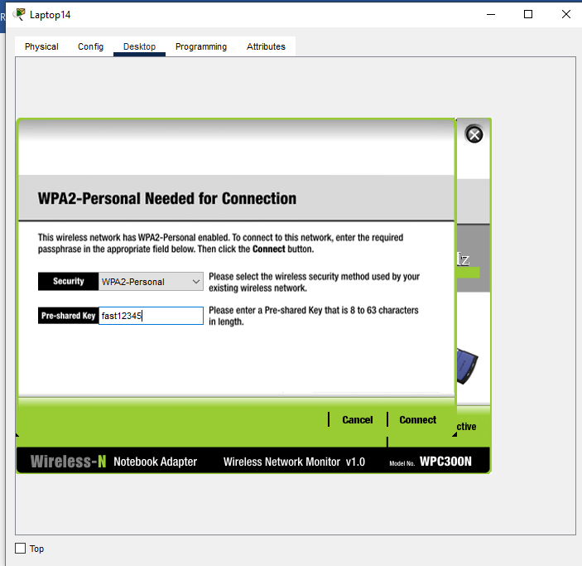
And we have successfully connected to the wireless connection.

Internet Setup Settings:

For this part, we’ll configure the internet interface on the router so as to connect
our LAN to the internet. Here, we’ll connect the internet interface to an ISP router which then connects to an internet server
we choose to configure a static IP address for the internet interface, we can also specify the default gateway and a DNS server .
now, we’ll set the internet interface to act as a DHCP client (with the DHCP
server configured on the ISP router we open our router and then go to cli and type in the following

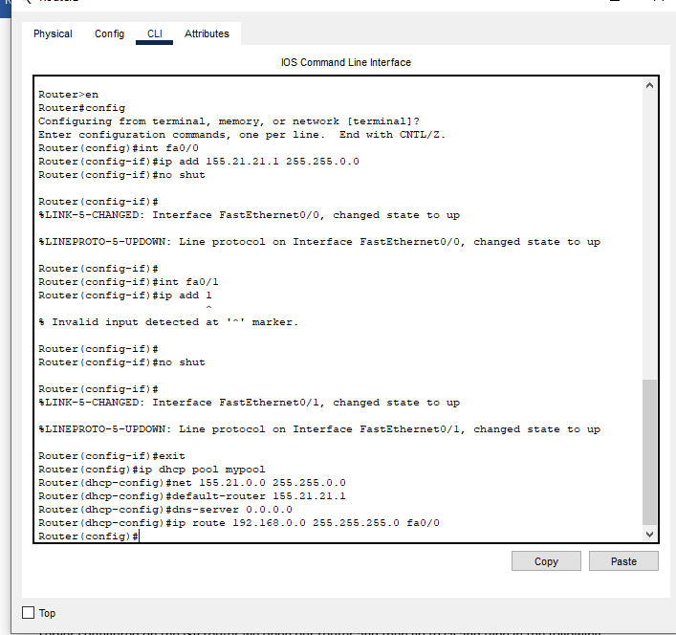

And make a DHCP connection with the wireless router by following these commands first we add the ip address 155.21.21.1 to the wireless router and thenn we make a pool name mypool in DHCP giving the ip address and the dns server and at the end we give the ip route through fa0/0

And then when we open our wireless router and go on internet and click on DHCP

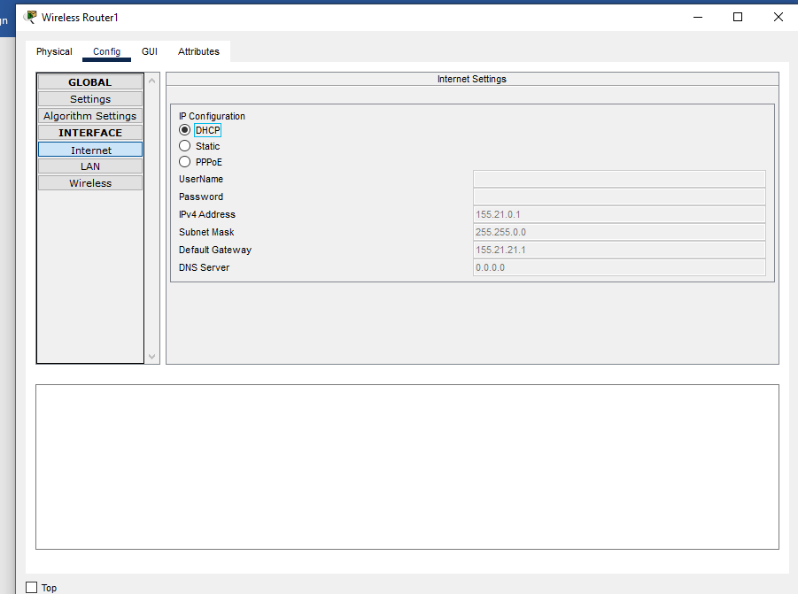

Our connection is successful.
Ping Testing The Server:
Then we ping the server.

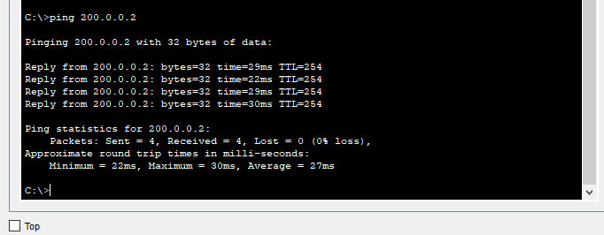

END.

